**CHAPTER 2 - JAVA SWING PROJECT**

**Switching from one window to the other** :

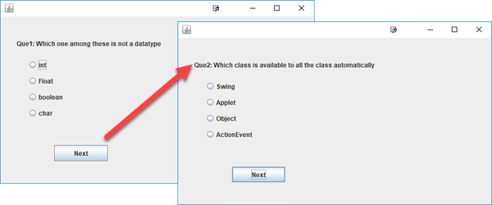

1. We need a question answer repository ready for this which can be accessed from this link

https://docs.google.com/spreadsheets/d/1rzoJCmz70NlHoCzn9jzJkZMP7Tme3qX9v-lSaes1TIM/edit#gid=739032675

Error : current =0 class interface or enum expected

Error : <identifier> expected current = current +1

Error : Exception in thread Null pointer exception

Elements used in programming

**JLabel** : JLabel is a class in java that is used to display single line of read only text.Here, the term read only means the reader cannot change this text.(**what**)

**JLabel()** : This is a constructor that creates an instance of JLabel with string value.As JLabel class is created string value is assigned(**what**)

**Radio Button(define)** : Radio button are used to select an option in a multiple choice question.(**what**)

**void setText(String)** : This is a JLabel method that is used to setText of the JLabel object.(**what**)

**JRadioButton** : JRadio Button is a class in Swing that is used to create Radio buttons(**what**)

**JRadioButton(String)** : JRadio Button is a constructor in Swing that is used to create Radio buttons with text and this is not selected.(**what**)

**JButton** : JButton is a class that is used to create la-belled button.(**what**)

**JButton(String)** : Here JButton() is a constructor that is used to label the button with the String.(**what**)

**ButtonGroup** : Used to create a group of button in which only we can select one button.(**what**)

**Creating a ButtonGroup** : Create a button group as

ButtonGroup G = new ButtonGroup();

1. add(b1);

G.add(b2);j

Here, b1 and b2 are radio buttons.

**ActionListener** : It is an event handler, used with object button . It will tell about the action performed when the button is clicked.The result is that an actionPerformed message is sent to all action listeners that are registered on the relevant component.(**what**)

**Step to write an ActionListener** :

1.Declare an event hadler class and declare the class either extends to the ActionListener or implements an ActionListener interface.

2.We add ActionListener to an instance or object of the class

E.g someComponent.addActionListener(instanceOfMyClass);

3. Include code that implements method in listener interface.

For more insight on actionListener refer to the link

https://examples.javacodegeeks.com/desktop-java/swing/java-swing-actionlistener-example/

**This keyword** : Keyword ****'THIS'**** in Java is a reference variable that refers to the current object.

* It can be used to refer current class instance variable
* It can be used to invoke or initiate current class constructor
* It can be passed as an argument in the method call

In our example it is referring to the current class.

**setBounds method** : The setBound method is used to set the position of the object.(**what**)

1. g b.setBounds(130,100,100, 40);//x axis, y axis, width, height

**e.getSource** : The EventObject contains the getSource( ) method.Suppose you have many buttons in your application. So, you can find which button is cliked by, using the getSource() method. The getSource( ) method returns the source of the event.

**add(button)** : This will add button to the frame. (**what**)

**setDefaultCloseOperation(JFrame.EXIT_ON_CLOSE)** :

The setDefaultCloseOperation() method is used to specify one of several options for the close button. Use one of the following constants to specify your choice:

* JFrame.EXIT_ON_CLOSE — Exit the application.
* JFrame.HIDE_ON_CLOSE — Hide the frame, but keep the application running.
* JFrame.DISPOSE_ON_CLOSE — Dispose of the frame object, but keep the application running.
* JFrame.DO_NOTHING_ON_CLOSE — Ignore the click.

**Common queries** :

1. **Now we don’t have an infinite loop so how is this program proceeding to the next statement** ?

Here, we have used ActionListener so as we click the button new frame is created with options and after last question if statement is not satisfied.

1. **Why have we have called the function set two times** ?

First time when current = 0 we don’t press next so program control is not transferred to set function so the value of label and option isn’t set therefore we are explicitly calling the set function.